**WebQuest – Exploration of NASA Space Place**

1. **What is a supernova?**

Find the following: 1) Picture of a **nebula,** 2) Picture of a **white dwarf**

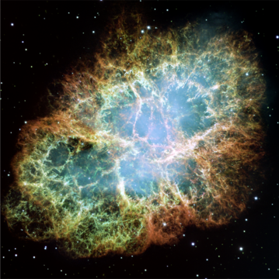 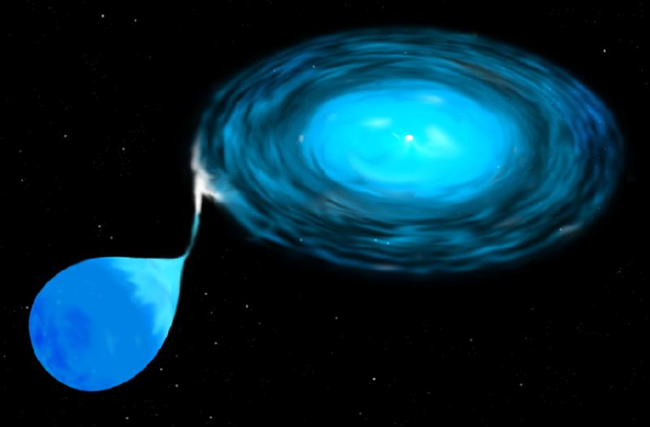

1. **What is an exoplanet?**

Answer the following: What is a **transit**?

When a planet passes in front of a star.

Find the following: 1) Picture of **Kepler**

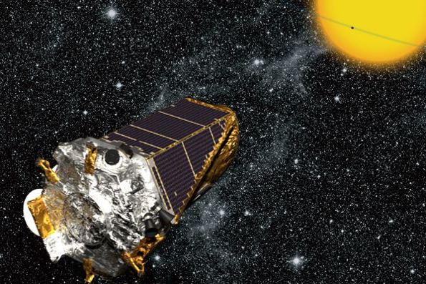

1. **Space Volcanoes**

Find the following: 1) Picture of **Triton**, 2) Picture of **Io**

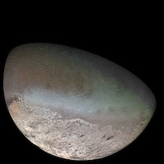 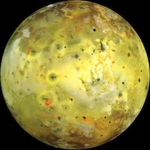

1. **What is a gravitational wave?**

Write down 3 events that could cause gravitational waves:

1. When a star explodes asymmetrically.
2. When two big starts orbit each other.
3. When two black holes orbit each other and merge.